Mobile App Development (CIS4034-N)

Sprint Review
Completion Details
Name: | Karan Desai | Date: | 14/12/2025
Sprint number: | 4 | Tutor: | Julien Cordry
Introduction
Sprint 4 focused on improving the internal architecture of the Smart Budget application by separating the user interface from the data and authentication logic. This sprint directly addressed feedback from the Product Owner, who recommended using a ViewModel to manage user information and authentication, following the Firebase and MVVM examples covered in Weeks 3, 5, and 6.
During this sprint, the login process was refactored so that authentication logic is handled inside a UserViewModel, while UI components such as the Login screen focus only on user interaction. A Dashboard screen was also implemented as a central hub after login, with navigation to Profile, Groups, and Expense Summary screens.

Review Details
Which user stories were accepted by the Product Owner?
The following user stories were accepted:
- User Login
  - As a user, I can log in using my email and password.
  - Authentication logic is handled through a ViewModel rather than directly in the UI.
- View User Overview
  - As a user, I can view my logged-in email on a Profile (User Overview) screen.
- Dashboard Navigation
  - As a user, I can access Profile, Groups, and Expense Summary screens from a central Dashboard.

- Password Visibility Toggle
  - As a user, I can show or hide my password while typing to reduce input errors.
These stories met the sprint goals and followed the architectural guidance provided by the Product Owner.

Which user stories were rejected by the Product Owner?

No user stories were formally rejected during this sprint.
However, the Product Owner noted that:
- Groups and Expense Summary screens currently act as functional placeholders.
- Full expense management and group sharing features are expected in later sprints.
This was considered acceptable for Sprint 4.

What feedback did the Product Owner give about the product and development team?
The Product Owner provided positive feedback on the following points:
- The separation of UI and data logic using a UserViewModel aligns well with MVVM principles.
- The login flow now follows the Firebase examples demonstrated in class.
- The application structure is cleaner, easier to maintain, and easier to explain during demonstrations.
- Navigation between screens is clear and user-friendly.
Suggested improvements for future sprints included:
- Expanding Firebase authentication handling (e.g., logout).
- Adding real data persistence for expenses.
- Improving UI polish and consistency.

What significant changes were made to the Product Backlog following the review?
The following changes were made to the Product Backlog after the review:
- Completed
  - Introduce UserViewModel for authentication and user data.
  - Refactor Login screen to remove business logic.
  - Add Dashboard with navigation to key features.
- Deferred to Sprint 5
  - Implement full expense tracking logic.
  - Implement group creation and management.
  - Add logout functionality.
  - Improve Firebase security rules and error handling.
These changes reflect a shift from architecture setup to feature completion in the next sprint.

Were any security concerns identified during the sprint that had not been predicted?

No unexpected security concerns were identified during Sprint 4:
However, the following considerations were noted.
- Firebase authentication error handling can be improved.
- Password validation and stronger feedback can be added in future sprints.
- Secure logout functionality should be implemented to prevent unauthorized access.
These concerns were added to the backlog for Sprint 5.

Evidence
- Screenshot 1 – Login Screen
- Demonstrates user login UI and password visibility feature.

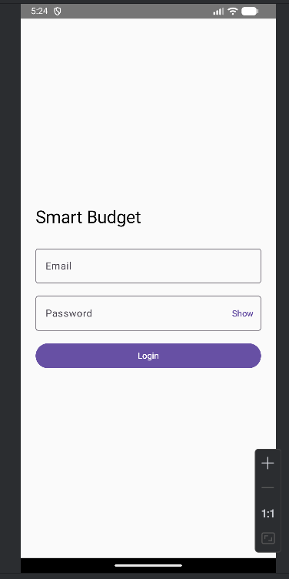

- Screenshot 2 – Successful Login, Dashboard.
- Confirms login flow and navigation works.

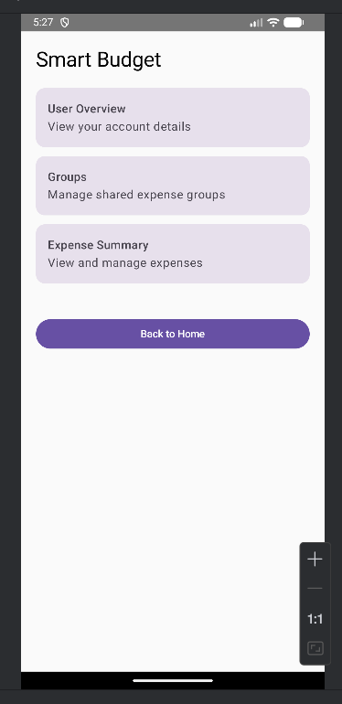

- Screenshot 3 – User Overview (Profile Screen)
- Demonstrates ViewModel storing and providing user data.

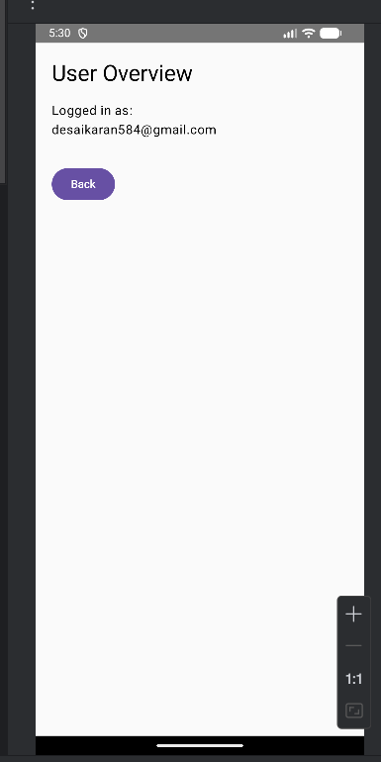

- Screenshot 4 – Groups Screen (Placeholder)
- Confirms screen navigation and placeholder functionality.

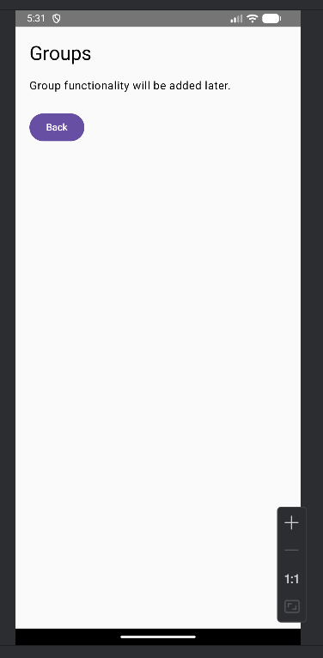
- Screenshot 5 – Expense Summary Screen (Placeholder)
- Confirms dashboard navigation and future feature readiness.

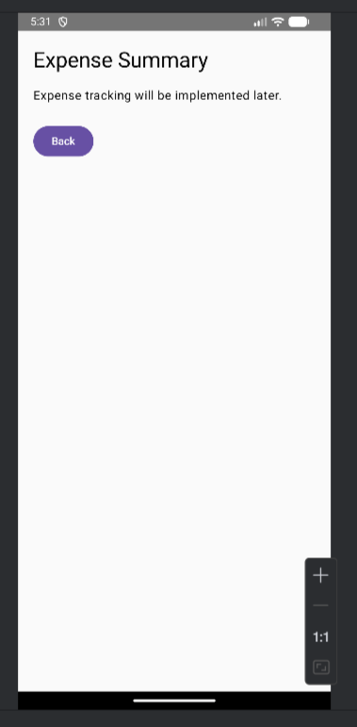

- Screenshot 6 – Navigation Back to Dashboard
- Demonstrates user-friendly navigation and app flow.

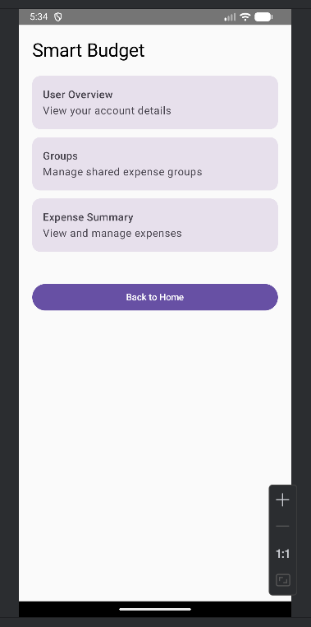

- Trello Board:

